**Project Report:** American

# Sign Language Recognition



**Name:** Gokul Hari

**Email**: 2k20cse048@kiot.ac.in

**Institute Name:** Knowledge Institute Of Technology

**Mentors:**

Mr. Utkarsh Sharma

Mr. Bassar Patel

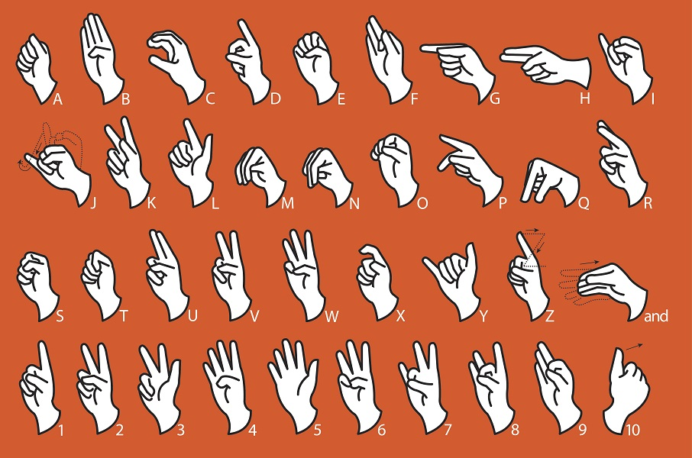

## Table of Content

|  |  |
| --- | --- |
| **Topic** | **Page No.** |
| Abstract | 1 |
| Introduction | 2 |
| Problem Statement and Objectives | 3 |
| Diagrams | 4 |
| Software Used | 6 |
| Implementation | 7 |
| Results | 10 |
| Conclusion | 13 |
| Future Scope | 14 |
| References | 15 |

**List of Tables**

|  |  |  |
| --- | --- | --- |
| **Table No.** | **Table Name** | **Page No.** |
| 1 | Softwares and Libraries used | 6 |
| 2 | Results | 12 |

**List of Figures**

|  |  |  |
| --- | --- | --- |
| **Figure No.** | **Figure Name** | **Page No.** |
| 1 | Inception V3 Architecture | 4 |
| 2 | Architecture of the Final Model | 4 |
| 3 | Block Diagram of the Model | 5 |
| 4 | Training and Testing data | 7 |
| 5 | Class names | 7 |
| 6 | Images in Training set | 8 |
| 7 | Loading InceptionV3 model | 8 |
| 8 | Adding Layers | 9 |
| 9 | Compiling and Fitting the model | 9 |
| 10 | Loss Graph | 10 |
| 11 | Accuracy Graph | 10 |
| 12 | Confusion Matrix | 11 |

## ABSTRACT

According to the World Federation of the Deaf, currently there are more than 70 million people who are deaf worldwide. Collectively, they use more than 300 different sign languages. Sign languages are fully fledged natural languages, structurally distinct from the spoken languages. The gestures or symbols in sign language are organised in a linguistic way. Each individual gesture is called a sign. Sign language helps deaf people to communicate with one another. In this project, I’ve created a machine learning model that recognizes sign language that is followed by the American Sign Language (ASL) format, from images. The model takes in an image and then predicts which alphabet or number is represented by that gesture. In this way, people who don’t understand Sign Language will be able to understand and interpret them using the machine learning model. Hence, this will bridge the gap of communication that exists in today’s world.

## INTRODUCTION

As such there is no universal sign language. Different countries adopt different sign languages. In India the Indian Sign Language (ISL) is used widely, in America there is the American Sign Language and so on. Some countries adopt features of American Sign Languages in their standard of sign language. ASL is a language completely separate and distinct from English. It contains all the fundamental features of language, with its own rules for pronunciation, word formation, and word order.

My main idea here is to create a machine learning model which will recognize and predict the sign from the images and display it, so that the user will understand which alphabet or number is shown in the hand sign gesture. Hence people who have not learned ASL will be able to understand what the other person wants to convey. This will help people to know about ASL and it will also create a better environment for the deaf.

## PROBLEM STATEMENT AND OBJECTIVES

***Problem Statement:***

To create a machine learning model that will be able to recognize the hand signs from images in the American Sign Language format.

***Objectives:***

1. To find a dataset having sufficient images following the ASL format.
2. To study about Neural Networks and how it can be used.
3. To split the dataset into training and testing sets.
4. To learn about Transfer Learning.
5. To create a model which gives a good accuracy.
6. To test the model’s accuracy on unseen(test) data.

**DIAGRAMS**

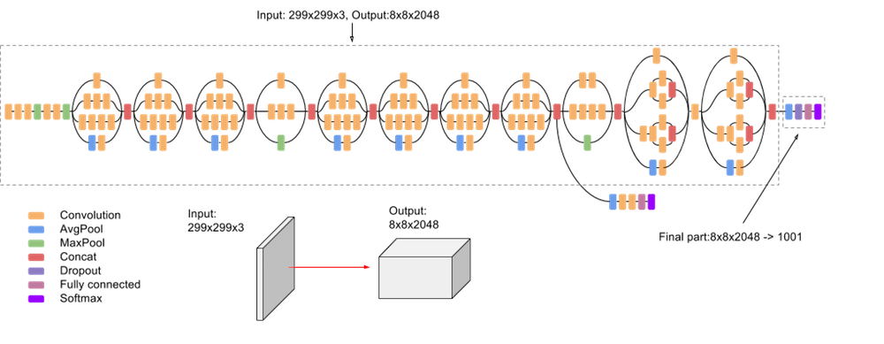

Fig 1. Inception V3 Architecture

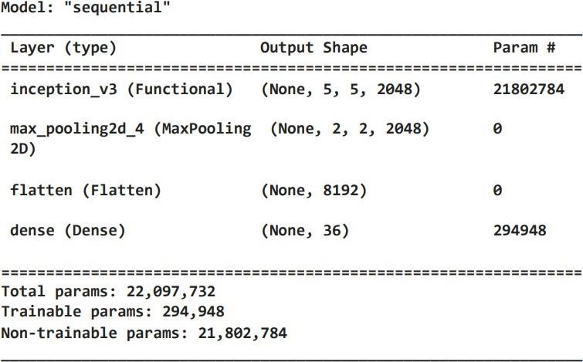

Fig 2. Architecture of the Final Model

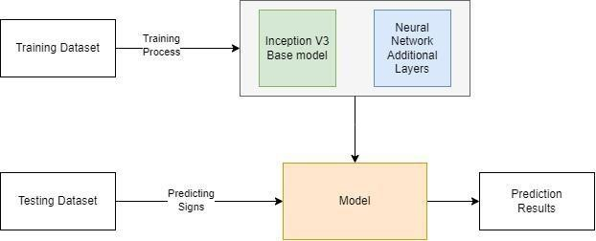

Fig 3. Block Diagram of the Model

## SOFTWARE USED

|  |  |
| --- | --- |
| **Name** | **Version** |
| **Python** | **3.10** |
| **Tensorflow** | **2.9** |
| **Keras** | **2.9** |
| **Matplotlib** | **3.1** |
| **Seaborn** | **0.12** |

Table 1. Softwares and Libraries used

## IMPLEMENTATION

Giving the path for the training and testing dataset. The training set contains 2012 images and the testing set contains 503 images.

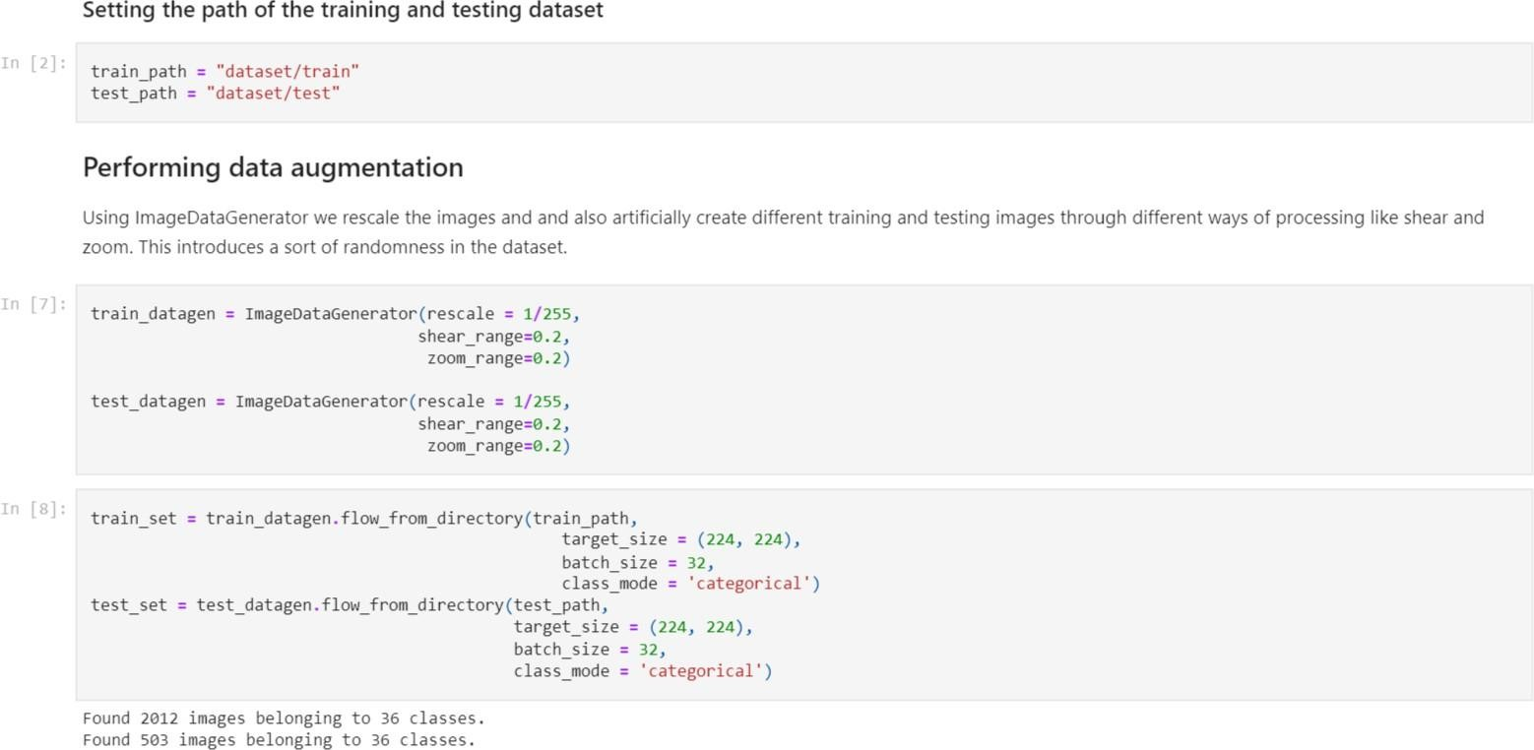

Fig 4. Training and Testing data

Storing the label names in a list.

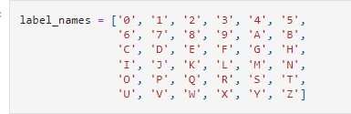

Fig 5. Class names

Plotting sample images from the training dataset.

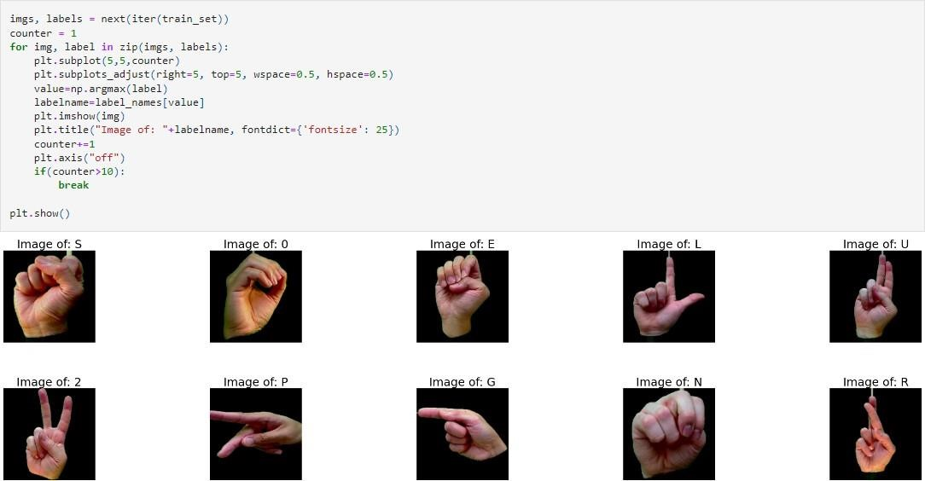

Fig 6. Images in Training set

Loading the InceptionV3 model as the base of our model and then making the layers trainable as false so that it doesn’t retrain and keep the same weights as before.

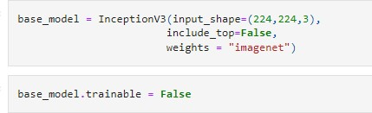

Adding a few more layers to the base model to create our own model.

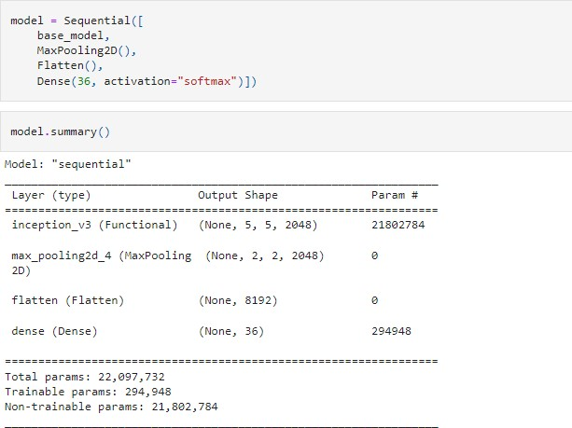

Fig 8. Adding Layers

**Compiling and fitting the model**

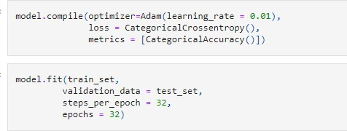

Fig 9. Compiling and Fitting the model

## RESULTS

**Training and Testing Loss graph**

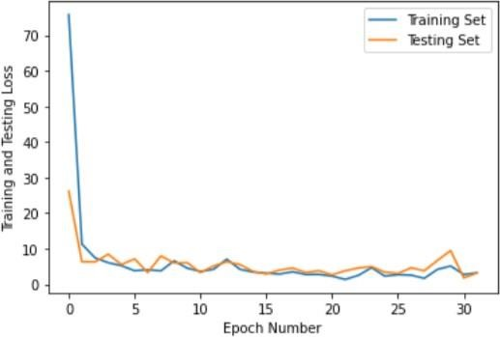

Fig 10. Loss Graph

**Training and Testing Accuracy graph**

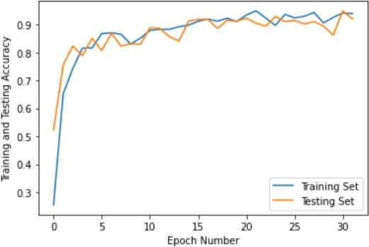

Fig 11. Accuracy Graph

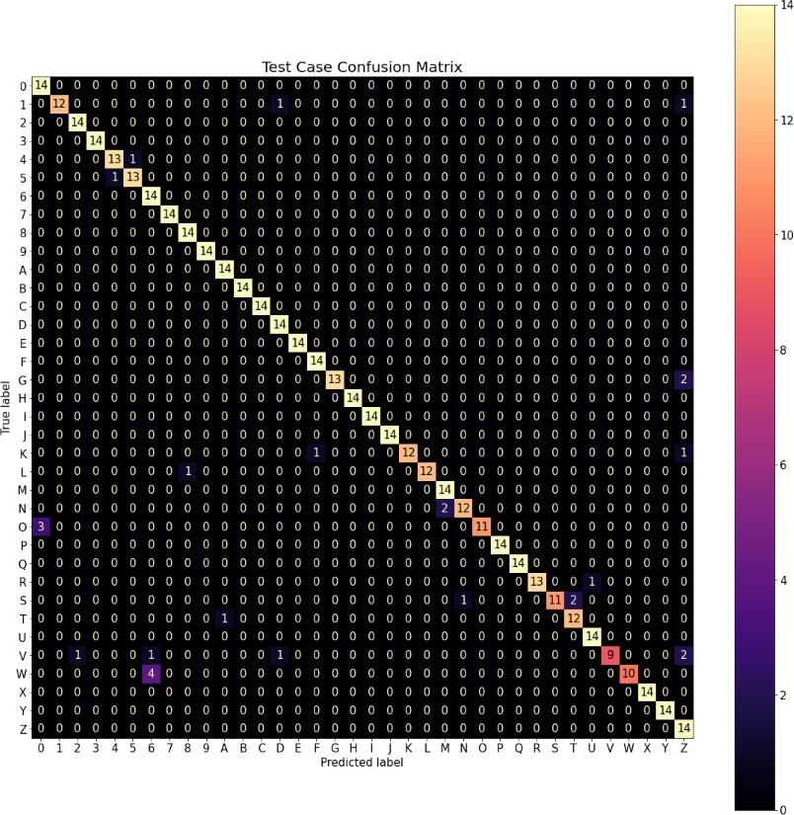

Fig 12. Confusion Matrix

|  |  |  |  |  |
| --- | --- | --- | --- | --- |
| **Model** | **Training Accuracy** | **Testing Accuracy** | **Training Loss** | **Testing Loss** |
| **93.92** | **92.64** | **3.24** | **3.91** |

Table 2. Results

## CONCLUSION

To conclude, I have successfully created a model that can recognize the signs with an **accuracy of 93%.** This model takes in the images of the sign and then predicts the output based on the American Sign Language . Categorical crossentropy was used to calculate the loss and Categorical accuracy was used to calculate the accuracy. To predict hand signs in different images, the images must be added in a folder and that path should be specified. Using evaluate and predict methods, we can understand what gesture was made.

## FUTURE SCOPE

The system can be further optimised and improved.

* Sequence of images can be passed to the model and the entire word could be recognized and shown as a list in the output.
* Live video recognition could be done through an external camera.
* The hand gesture can be highlighted and its class can be shown beside it on the screen.
* We can develop a model for ASL word and sentence level recognition
* We can develop a complete product that will help the speech and hearing impaired people, and thereby reduce the communication

gap.

## REFERENCES

1. D. Patel, “Deep learning with tensorflow 2.0, Keras and python,” *YouTube*. [Online]. Available: [https://www.youtube.com/playlist?list=PLeo1K3hjS3uu7CxAacxVndI4bE_o3BDtO.](http://www.youtube.com/playlist?list=PLeo1K3hjS3uu7CxAacxVndI4bE_o3BDtO)

1. Simplilearn, “AI and Machine Learning Full Course | Artificial Intelligence & Machine Learning course simplilearn, ”*YouTube*,Available: [https://www.youtube.com/watch?v=wnqkfpCpK1g..](http://www.youtube.com/watch?v=wnqkfpCpK1g)

1. “A study on CNN transfer learning for Image Classification - Researchgate.” [Online]. Available:[https://www.researchgate.net/publication/325803364_A_Study_on_CNN_Transfer_Le arning_for_](http://www.researchgate.net/publication/325803364_A_Study_on_CNN_Transfer_Learning_for)Image_Classification.

1. D. Patel, “Machine learning tutorial python | machine learning for beginners,” *YouTube*, 2018. [Online].Available:[https://www.youtube.com/playlist?list=PLeo1K3hjS3uvCeTYTeyfe0rN5r8zn 9rw.](https://www.youtube.com/playlist?list=PLeo1K3hjS3uvCeTYTeyfe0rN5r8zn9rw)

1. “(PDF) introduction to artificial neural networks - researchgate.” [Online]. Available:

[https://www.researchgate.net/publication/5847739_Introduction_to_artificial_neural_networks.](http://www.researchgate.net/publication/5847739_Introduction_to_artificial_neural_networks)